**TASK-08**

Fat Gram Calculator

**EXPLANATION:**

The program asks the user to enter the total calories in the food and then fats. The program then calculates the fat grams in the food. If the calories of fats are less than 30% of total calories then the program displays a message that food is low in fat. If the user enters a character or a negative value, the program then gives an error and then again asks the user to enter the fat grams or the calories

**INPUT:**

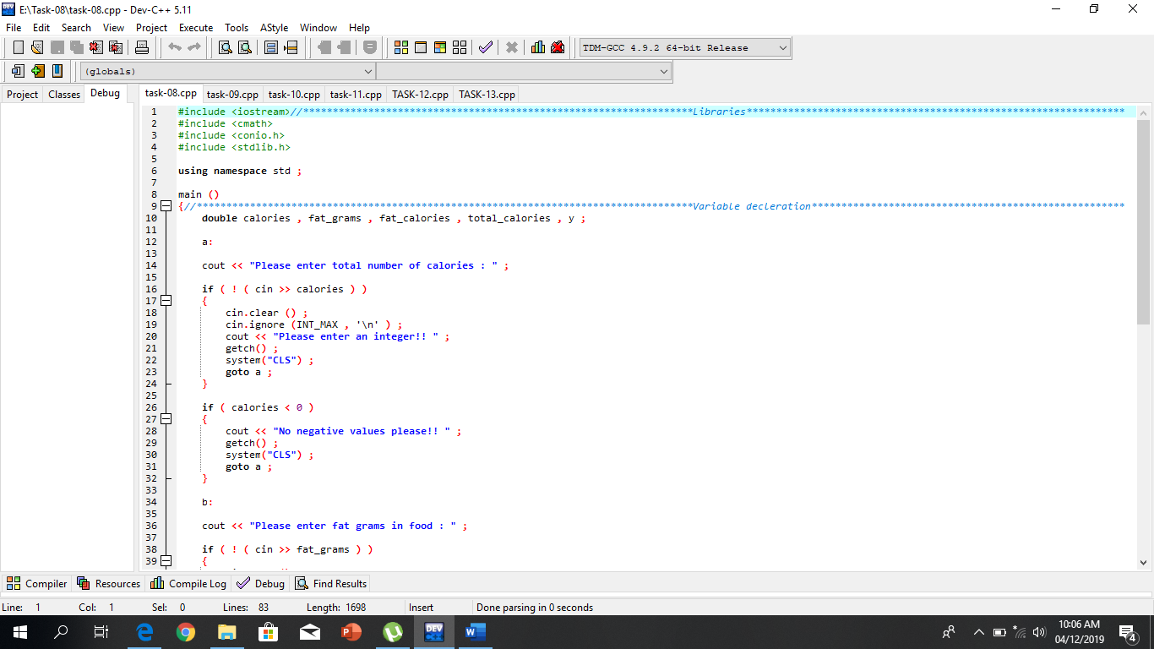

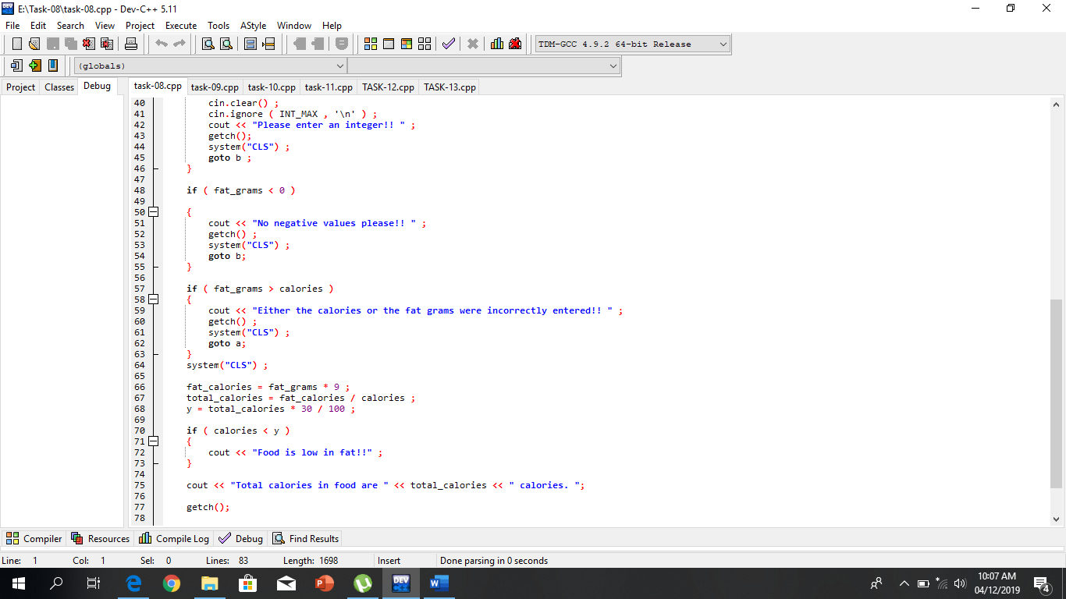

**OUTPUT:**

